YEAR 12 CHEMISTRY - 3ACHE

TEST 3- 2013

Acids and Bases

/55
Recommended time: 1 hour

Name: ANSWERS

PART 1:
Questions 1-15

1 | a b  c  d  |  | 9 | a b  c  d 
2 | a b  c  d  |  | 10 | a b  c  d 
3 | a b  c  d  |  | 11 | a b  c  d 
4 | a b  c  d  |  | 12 | a b  c  d 
5 | a b  c  d  |  | 13 | a b  c  d 
6 | a b  c  d  |  | 14 | a b  c  d 
7 | a b  c  d  |  | 15 | a b  c  d 
8 | a b  c  d 
(15 marks)

PART 2: WRITTEN SECTION (25 marks)

This section has five short answer type questions. Write your answers using blue or black pen in the spaces provided. This part is worth a total of 25 marks.

1. Write balanced ionic equations and give observations for the reactions that occur between the following reactants. Also write the observation that would occur as the reaction proceeded. [Total 9 marks]

(a) Cobalt (II) hydroxide solid is added to 1 mol L⁻¹ Hydrochloric acid (a) Cobalt (II) hydroxide solid is added to 1 M Hydrochloric acid solution.

Equation: Co(OH)₂(s) + 2 H⁺(aq) → Co²⁺(aq) + 2 H₂O(l)
______________________________________________________[2 marks]

Observation: Pink solid turns into a pink solution___ [ 1 mark]

(b) Nitric acid solution is added to solid calcium hydroxide powder and heated.

Equation: Ca(OH)₂(s) + 2 H⁺(aq) → Ca²⁺(aq) + 2 H₂O(l)
______________________________________________________[2 marks]

Observation: White solid dissolves to colourless solution
[1 mark]

(c) Oxalic acid acid crystals, H₂C₂O₄ (you may consider them anhydrous for this equation), are added to a solution of universal indicator in neutral water. Show the dissociation
equation of just one hydrogen ion per molecule.

Equation: H₂C₂O₄ (s) → H⁺(aq) + HC₂O₄― (aq)
(also H₂O and H₃O⁺ as reactant and product are correct)
[2 marks]

Observation: yellow colour of UI. becomes redder or orange.[1 mark]

2. Five clear solutions, whose formulas are shown below, are to be identified by carrying out the testing shown in the FLOW CHART below. Write the formulas of the substances that would be recorded in the empty boxes so that finally all 5 would be identified.
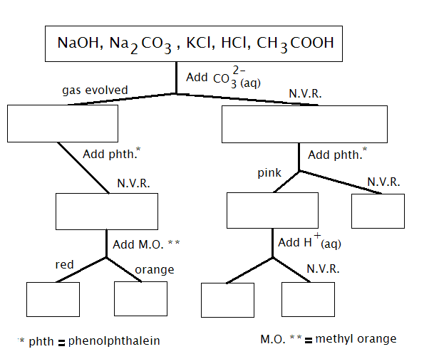
Plus 1 mark bonus if all correct. If answer is reversed, only deduct 1 mark [6 marks]

HClCH₃COOH
Add red litmus paper
HClCH₃COOH
Add red litmus paper
CH₃COOH
(1)

Add universal indicator
HCl
(1)

Blue
KCl
(1)

NaOH Na₂CO₃KCl
NaOH Na₂CO₃
Na₂CO₃
(1)

NaOH
(1)

3. When 0.020 moles of barium hydroxide solid is added to 800 ml of 0.010 mol L⁻¹NaOH,eventually a clear solution is formed.

a) Calculate the final OH―(aq) concentration.

Moles of OH― from Ba(OH)₂ solid = 0.02 x 2 = 0.04 mol
Moles of OH― from NaOH solution = CV = 0.010 x 0.800 = 0.0080 mol
Total moles = 0.048mol
[OH― ]= 0.048/0.800 = 0.060 molL⁻¹
[3 marks]

b) Calculate the final pH of the mixture, assume the final volume remains at 800 ml.

[H⁺] = 10⁻¹⁴ / 0.06 = 1.667 x 10⁻¹³ molL⁻¹

pH = 12.78
[2 marks]

4. If 125 ml of HCl having pH of 2.0 is added to 540 ml of HNO₃ of pH 3.0. Calculate the pH of the final solution.
[5 marks]
Moles H⁺ from HCl = 10⁻² x 0.125 = 1.25 x 10⁻³mol (1)

Moles H⁺ from HNO₃ = 10⁻³ x 0.540 = 5.4 x 10⁻⁴mol (1)

Tot moles = 1.79 x 10⁻³mol, Tot vol = 665 mL (1)

[H+] = 1.79 x 10⁻³mol / 0.665L = 2.69 x 10⁻³ molL⁻¹ (1)

pH = 2.57 (1)

Part 3.PRACTICAL TEST: pH OF SALT SOLUTIONS

In experiment 10, you tested the pH of a number of salts.

Using your understanding gained from conducting this experiment, complete the following table:

Complete the following table.[15 marks]
(½ )(½ ) (2)
Solute  (0.1 mol L⁻¹) | Colour of Universal Indicator | pH of solution  ( < 7, = 7 or > 7 ) | Explanation  (Write an equation when appropriate)
Potassium  nitrate | Green | 7 | Both potassium and nitrate ions are neutral and do not react with water
Ammonium  chloride | Yellow/ orange | <7 | NH₄⁺ + H₂O → NH₃ +H₃O⁺  Hence acidic.
Sodium  carbonate | Blue | >7 | CO₃²⁻ + H₂O → HCO₃― + OH―  Hence basic.
Sodium acetate  [NaCH₃COO] | Blue | >7 | CH₃COO― + H₂O →CH₃COOH +OH―  Hence basic.
Sodium Hydrogen  Carbonate | Blue | >7 | HCO₃― + H₂O →H₂CO₃ +OH―  Hence basic.

END OF TEST

